Space Invaders

By Mike Gold

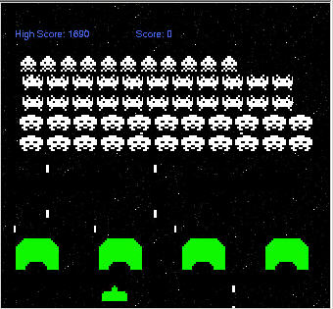

Introduction

Space Invaders is a revival of the original space invaders game written in C# and .NET. The object of the game is to shoot as many invaders as you can without getting shot yourself. Be careful, those invaders keep coming down at you!

Points

The highest points are scored in the top row (50 each) because they are harder to hit, the lowest points are scored in the bottom row (10 each). Every once in a while, a surprise flying saucer zooms across the screen and you have an opportunity to shoot it down.

Shields

You can hide behind shields to dodge missles. Your shields will eventually erode away, though, because they are getting shot up.

